Interface ID: 30
Created by: Mark Lund
Created Date: 8-26-2004

Description of Design Concept:
The WSP Driver Inquiry process is a Windows Service that accepts driver inquiry messages from WSP. WSP sends the inquiry message to DOL via the vsMSSGatewayDB service which places the message in a “Driver” MSMQ queue. The dsdDriverInquiryService reads the message from the “Driver” queue, calls the MAXSO web service to obtain the data and returns the data to WSP via the DBQTx queue and the vsMSSGatewayDB service.

Decomposition/Flow Diagram: 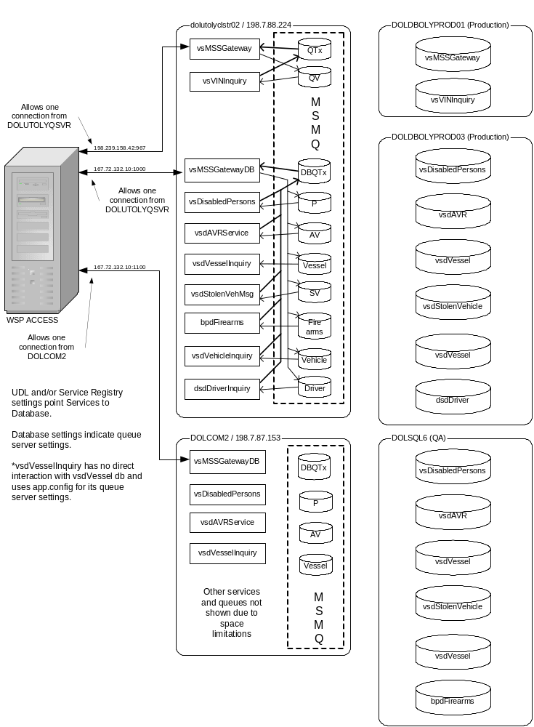
WSP – DOL Queue Environment

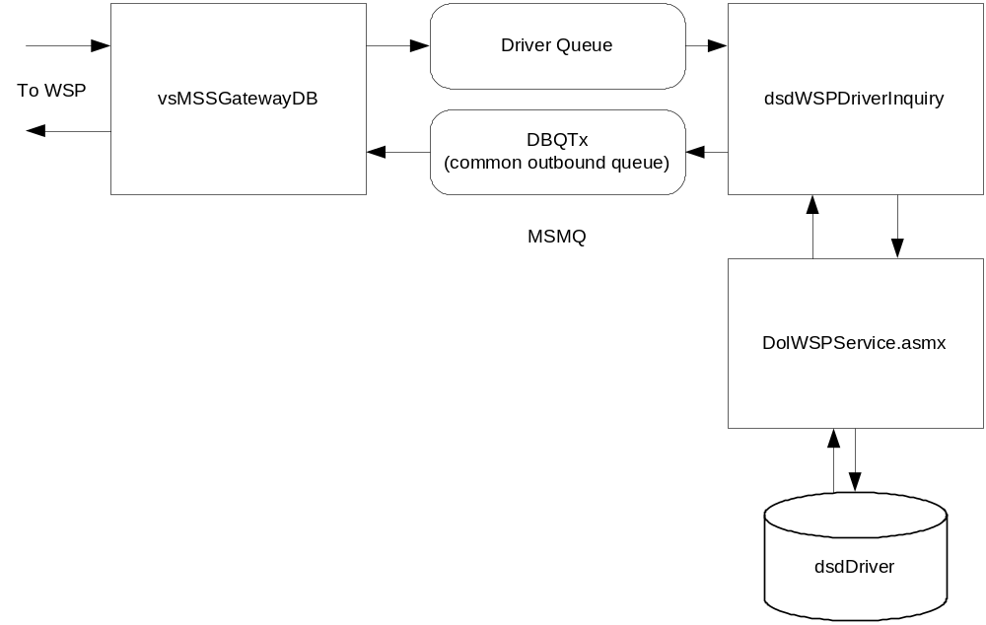
Message Transaction Flow

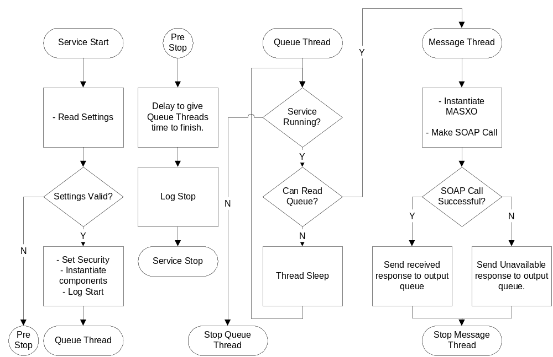
Code Flow

Functional Specifications:

Component Name: dsdWSPDriverInquiry.exe
Functionality:
- The main process and runs as a Windows Service. The Code Flow diagram shows the general flow of the program.
- The process supports multiple threads to improve performance. The number of threads are controlled via dsdWSPDriverInquiry.exe.config file settings.
- Timing, the web service security context, and queue information is also stored in the dsdWSPDriverInquiry.exe.config file. If changes are made to the dsdWSPDriverInquiry.exe.config, the service must be stopped/re-started since the config file values are only read at start-up time.
- To make the web service call as a specific user account, set the Username, Password, and Domain values of the desired Windows user account. Note – the UseSystemCredentials key is ignored when defining specific user credentials.
- To make the web service call as the user account under which the service runs, set Username, Password, and Domain values to empty strings, set the UseSystemCredentials key to “True” and configure the service to run under the desired account.
- To make the web service call as anonymous, set the Username, Password, and Domain values to empty strings and set UseSystemCredentials to “False”. When no credentials are defined, the service will make the call anonymously.
- The Code Flow diagram above shows the primary flow.

Component Name: WA.DOL.VSD.WSPQueue
Functionality:
- This component encapsulates the MSMQ queue functionality and the WSP Message formatting. This re-usable component was developed as part of UAR Vessels and was used for UAR Vehicles and the Stolen Vehicle project.

Unit Test Specifications:
Testing of the dsdWSPDriverInquiry process occurs through the ACCESS switch. For Production testing, any WSP Test Terminal will suffice using the URL http:access.wsp.wa.gov. For QA testing, the inquiry must originate from a special test terminal currently located on floor 3 of blk1. See Kimberly Mathis or Mary Whitford.

1. Open Internet Explorer
2. Enter the following URL
http://access.wsp.wa.gov – Production
http://access.wsp.wa.gov:90/webmss/index.html - test
3. If Production, select the "Non-WSP WebMSS Terminal - (IGN)" link to access the terminal window. Click “OK” or “Yes” to any certificate message boxes that are displayed.

To use the WSP test terminal:
1. Logon by typing ON.ACCESS.USER and then clicking the "Send" button.
2. Enter the desired inquiries using the following format (note – only enter one at a time):

D;D..<insert PIC here>
D;K..<insert PIC here>

Examples:
D;D..ABBOTWS506M9
D;K..ABBOTWS506M9

3. Click "Send" to send an inquiry.
4. Wait until the lower left "NORM" lights up in red. Click the Receive button
to receive the response.
5. When finished, be sure to log off of the WSP ACCESS switch by typing "OFF" and clicking "Send" before closing the browser.

Other Valid Input String Formats
Driver Inquiry by PIC with Mnemonic:
D;D..OLN/ABBOTWS506M9

Driver Inquiry by name and DOB MMDDYY w/out Mnemonic:
D;D..ABBOTWS072950

Driver Inquiry by name and DOB MMDDYY with Mnemonic:
D;D..NAM/ABBOTWS072950

Driver History by PIC with Mnemonic:
D;K..OLN/ABBOTWS506M9

Driver History by name and DOB MMDDYY w/out Mnemonic:
D;K..ABBOTWS072950

Driver History by name and DOB MMDDYY with Mnemonic:
D;K..NAM/ABBOTWS072950

